# **UNIVERSIDAD NACIONAL DE INGENIERIA**

## **FACULTAD DE CIENCIAS**

## CIENCIAS DE LA COMPUTACION



**Título del Trabajo**

**Practica Calificada 5: Modelamiento Dinámico**

**Autores**

Lázaro Camasca Edson Nicks

**Curso**

## Inteligencia Artificial

**Profesor**

Antonio Morán

Lima – Perú

**(2019)**

1. **Planteamiento del problema**

En este informe trabajaremos con un programa para el entrenamiento de una red neuronal dinámica para modelar un sistema no lineal utilizando el algoritmo DBP.

El sistema tiene 1 entrada y 2 señales de salida, variaremos los valores de centro, porcentaje de error.

1. **Primer intento:**
   1. **Entrenamiento_ U1:**

|  |  |
| --- | --- |
| Datos iniciales | Automático |
| learning rate [v w] | 0.02 |
| learning rate [c: sigmoid center] | 0.05 |
| learning rate [a: sigmoid slope] | 0.05 |
| maximum value of error function (percentage %): | 10 |
| number of iteration steps | 1000 |
| erreltotal | 0.0991 |

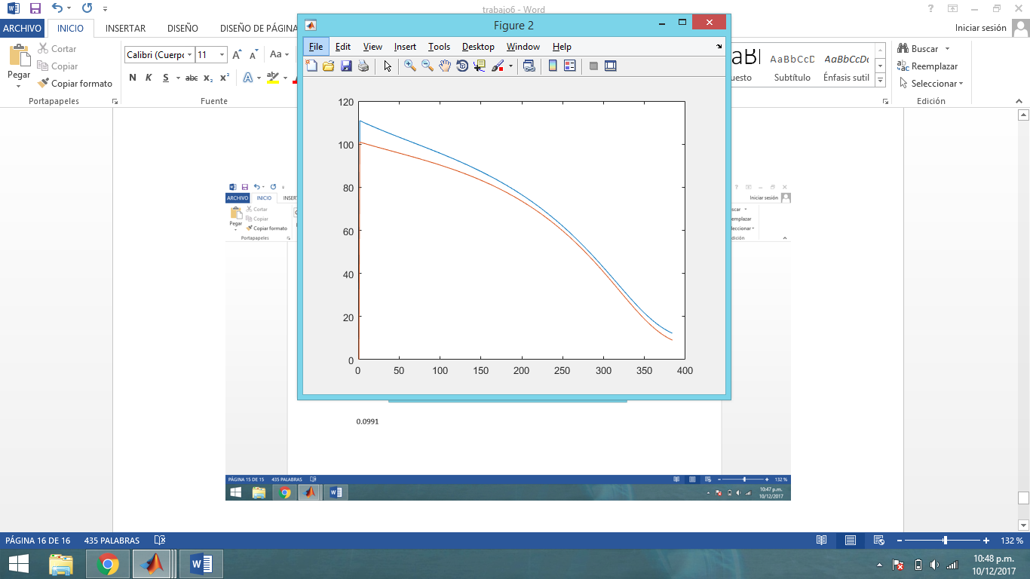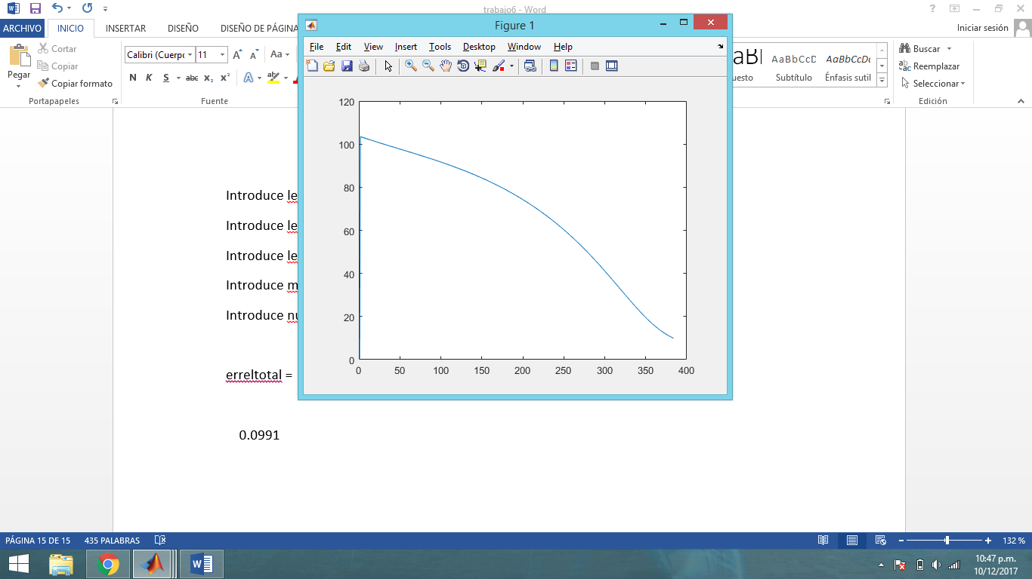

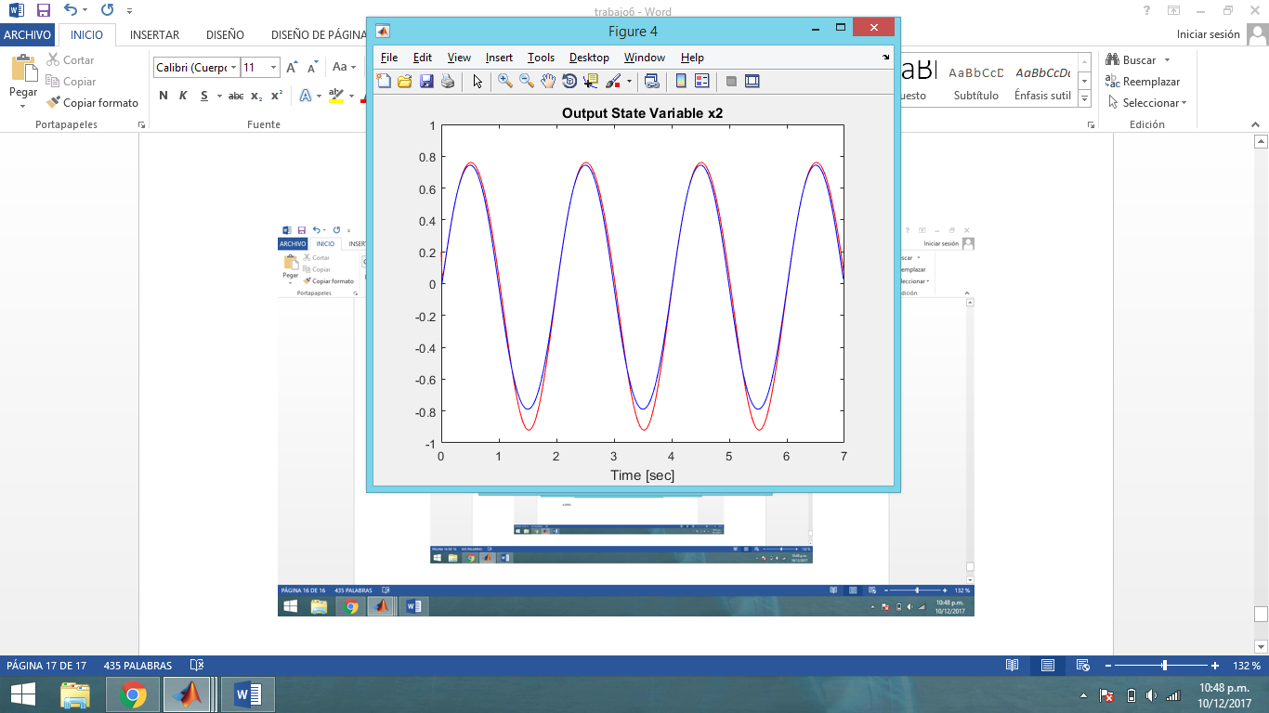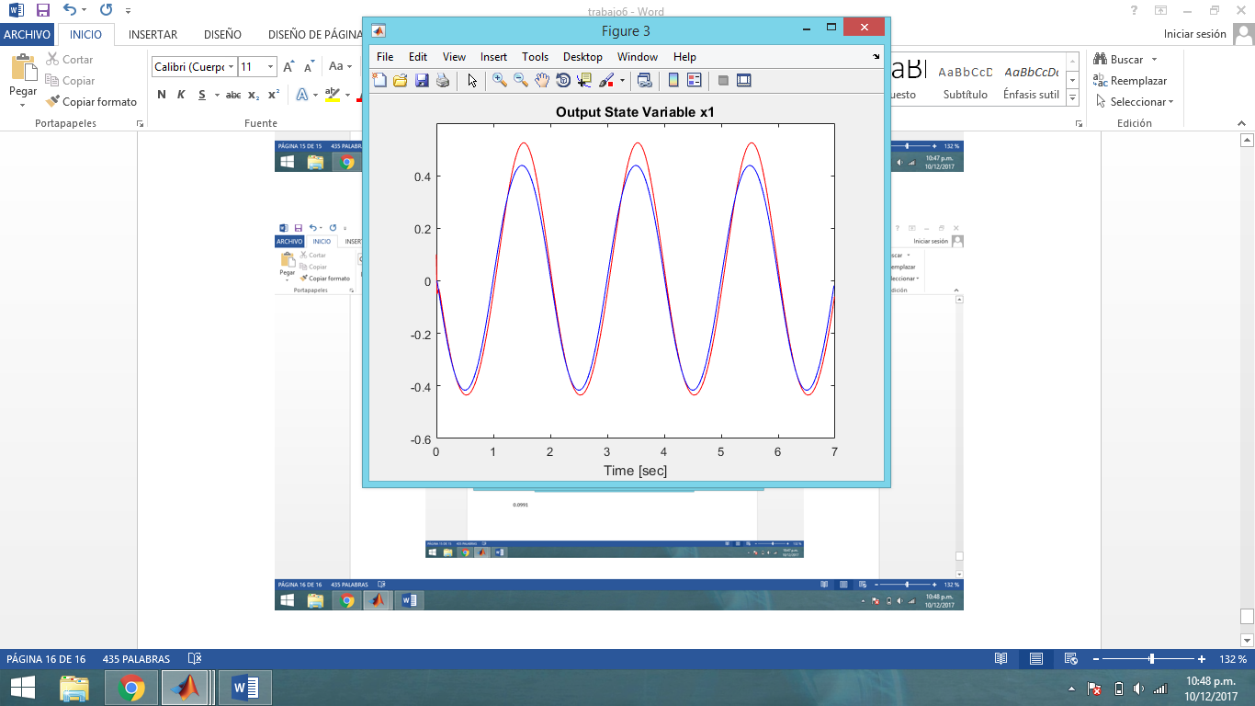

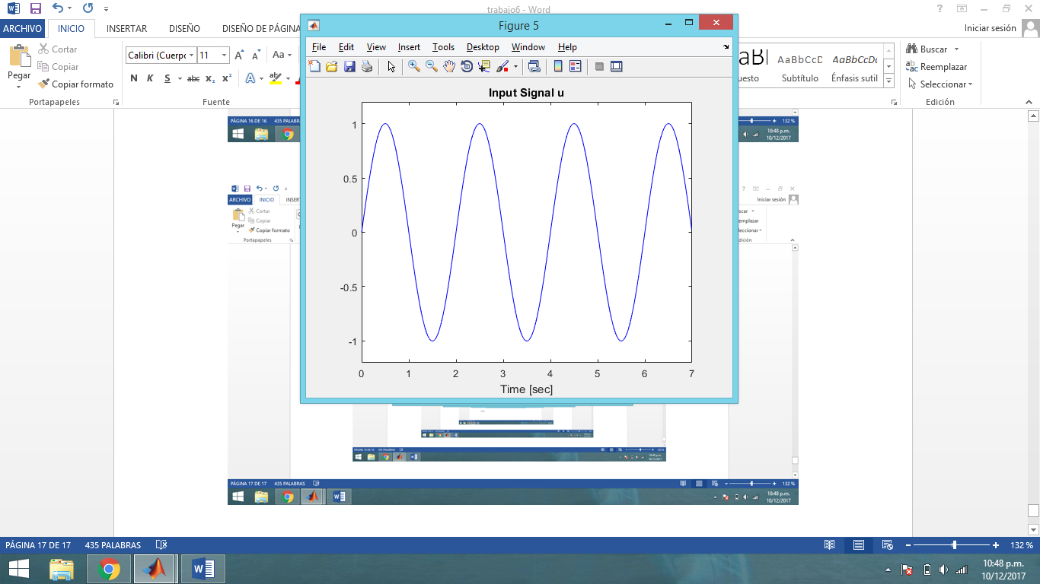

* 1. 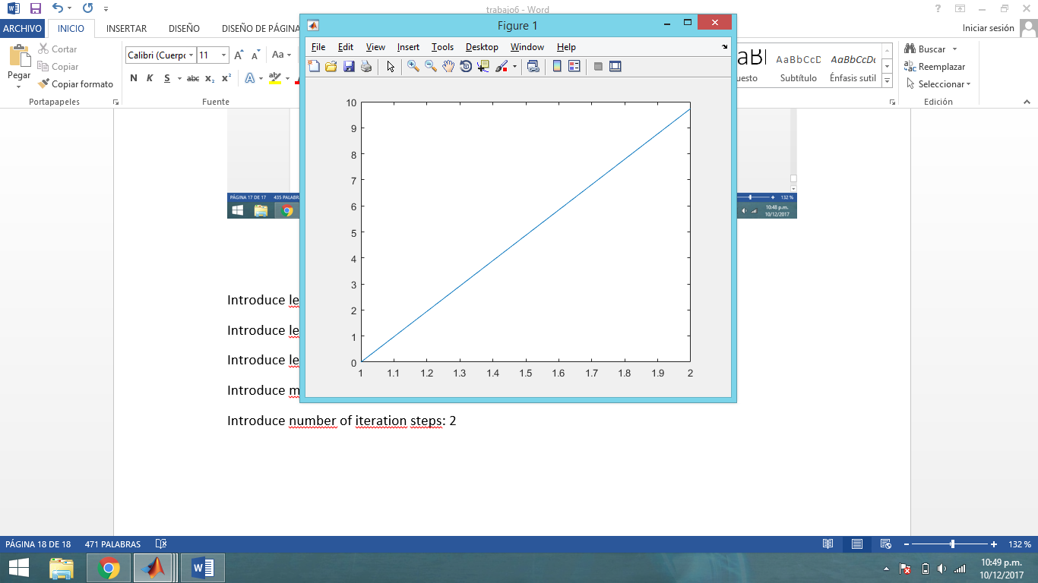**Validando_ U2:**

|  |  |
| --- | --- |
| Datos iniciales | Automático |
| learning rate [v w] | 0 |
| learning rate [c: sigmoid center] | 0 |
| learning rate [a: sigmoid slope] | 0 |
| maximum value of error function (percentage %): | 10 |
| number of iteration steps | 2 |
| erreltotal | 0.0982 |

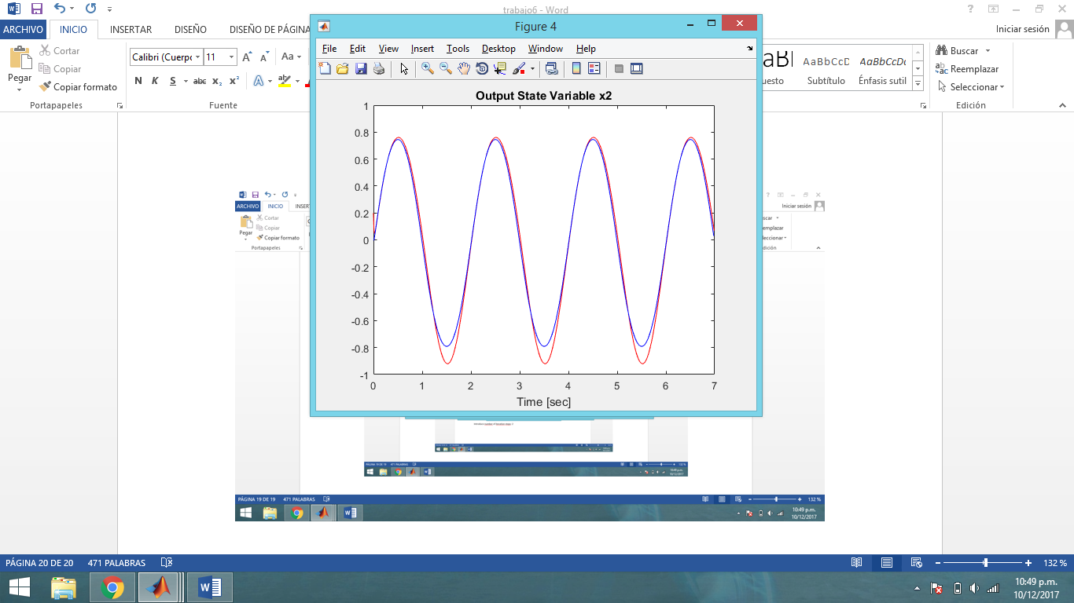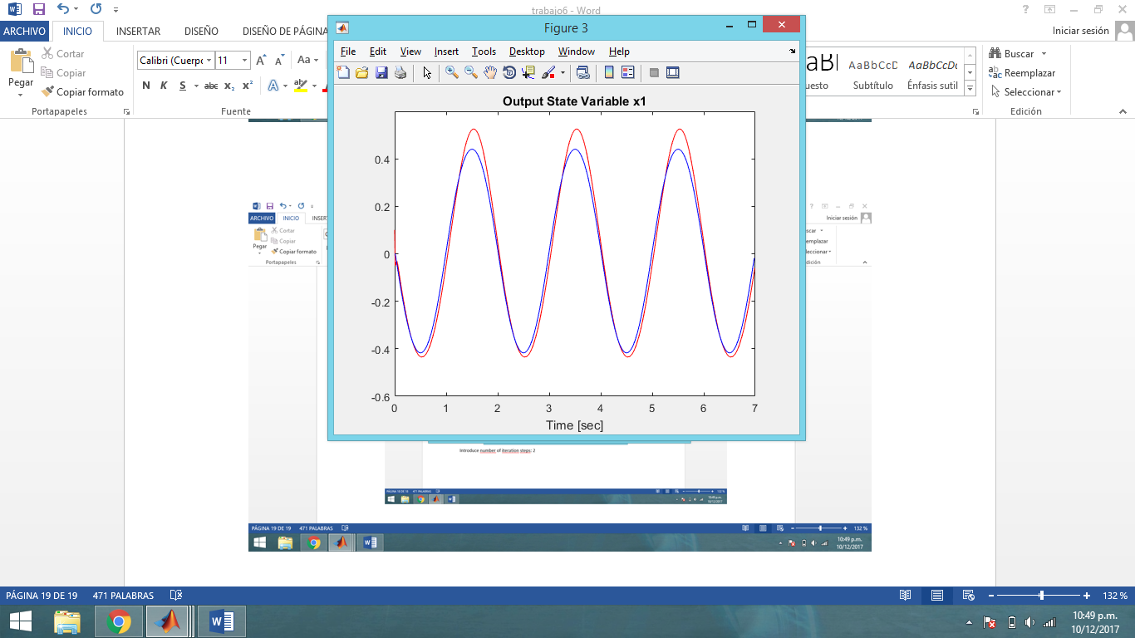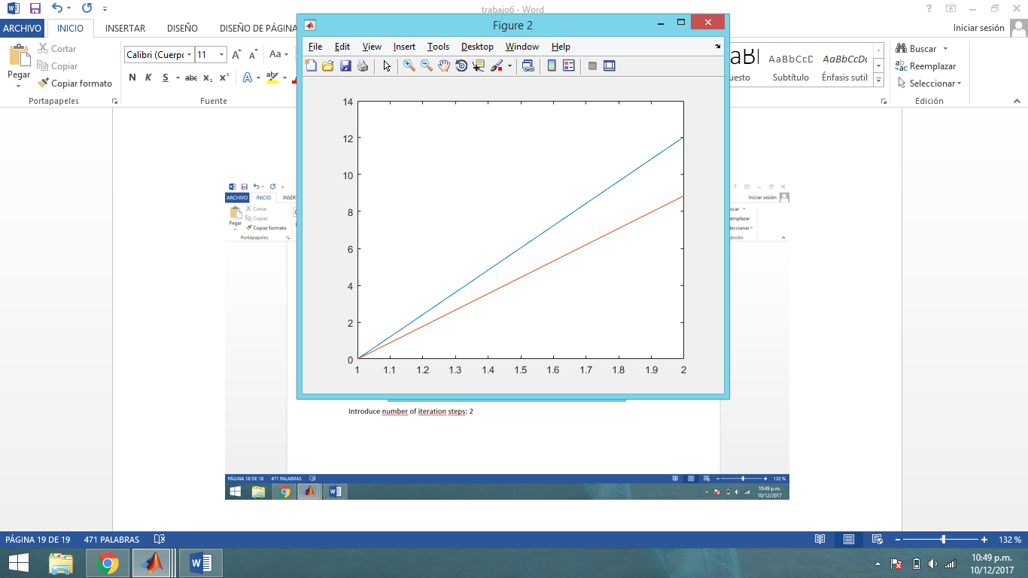

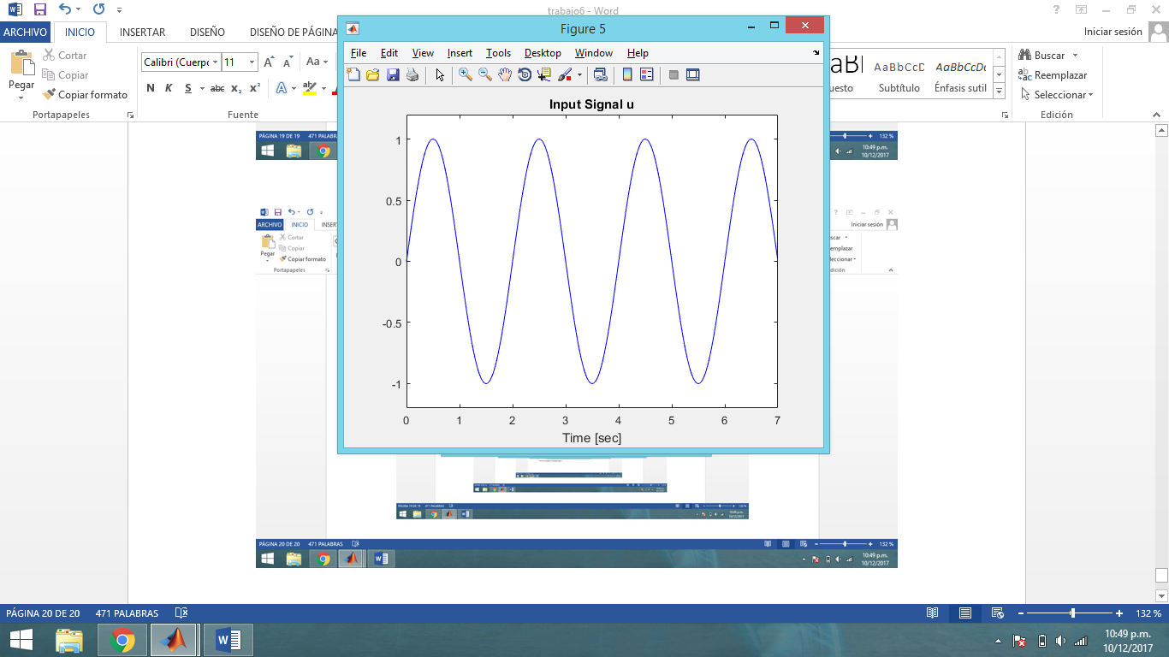

* 1. **Validando_ U3:**

|  |  |
| --- | --- |
| Datos iniciales | Automático |
| learning rate [v w] | 0 |
| learning rate [c: sigmoid center] | 0 |
| learning rate [a: sigmoid slope] | 0 |
| maximum value of error function (percentage %): | 10 |
| number of iteration steps | 2 |
| erreltotal | 0.0989 |

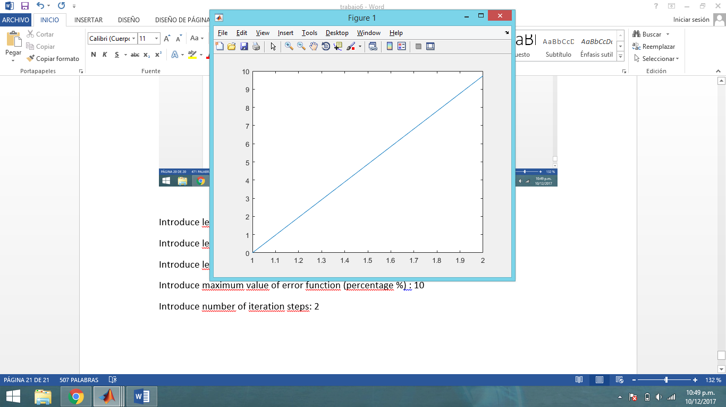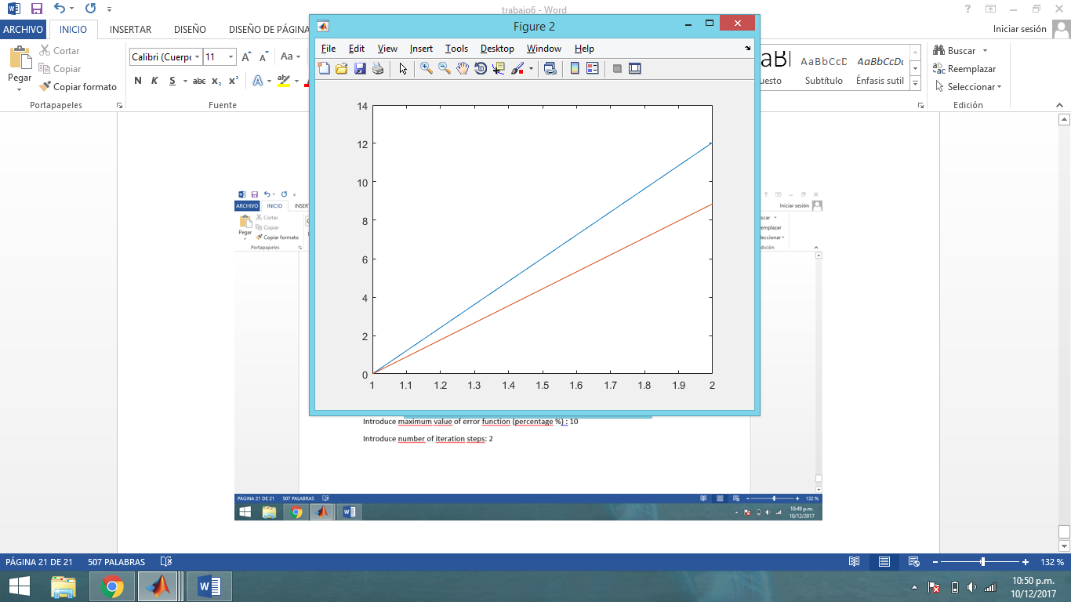

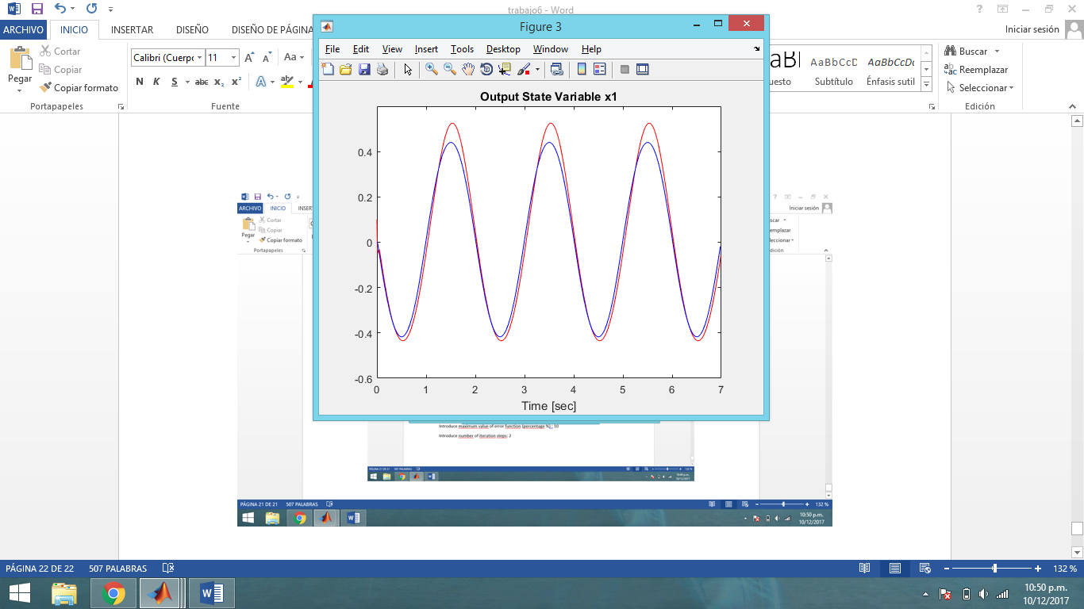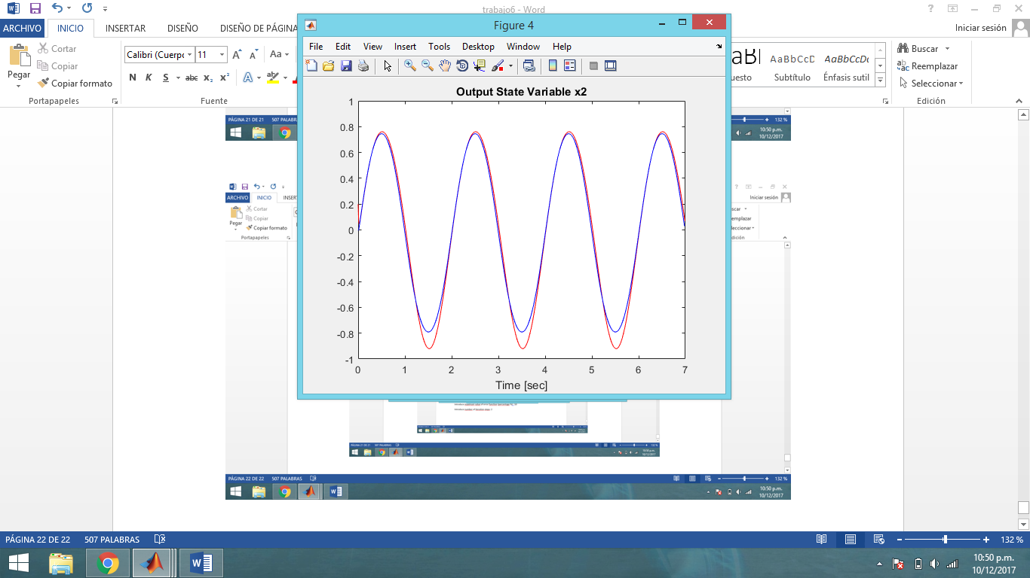

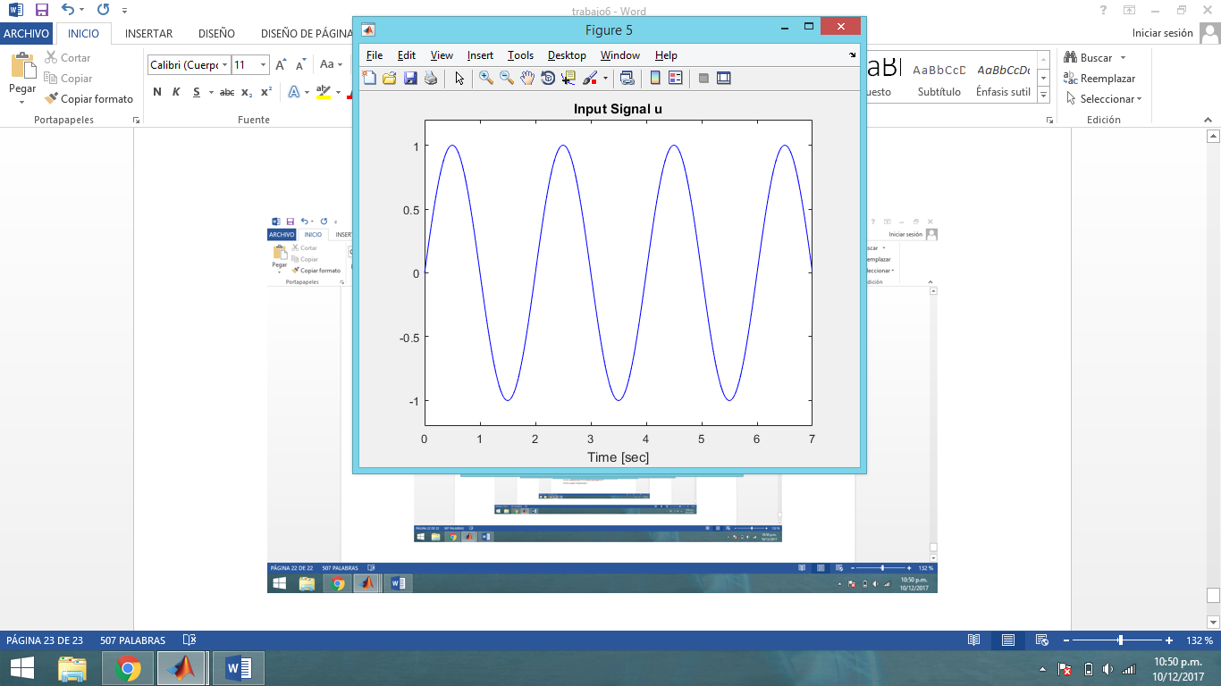

1. **Segundo intento:**
   1. **Entrenamiento_ U1:**

|  |  |
| --- | --- |
| Datos iniciales | Automático |
| learning rate [v w] | 0.08 |
| learning rate [c: sigmoid center] | 0.05 |
| learning rate [a: sigmoid slope] | 0.05 |
| maximum value of error function (percentage %): | 9 |
| number of iteration steps | 1000 |
| erreltotal | 0.0880 |

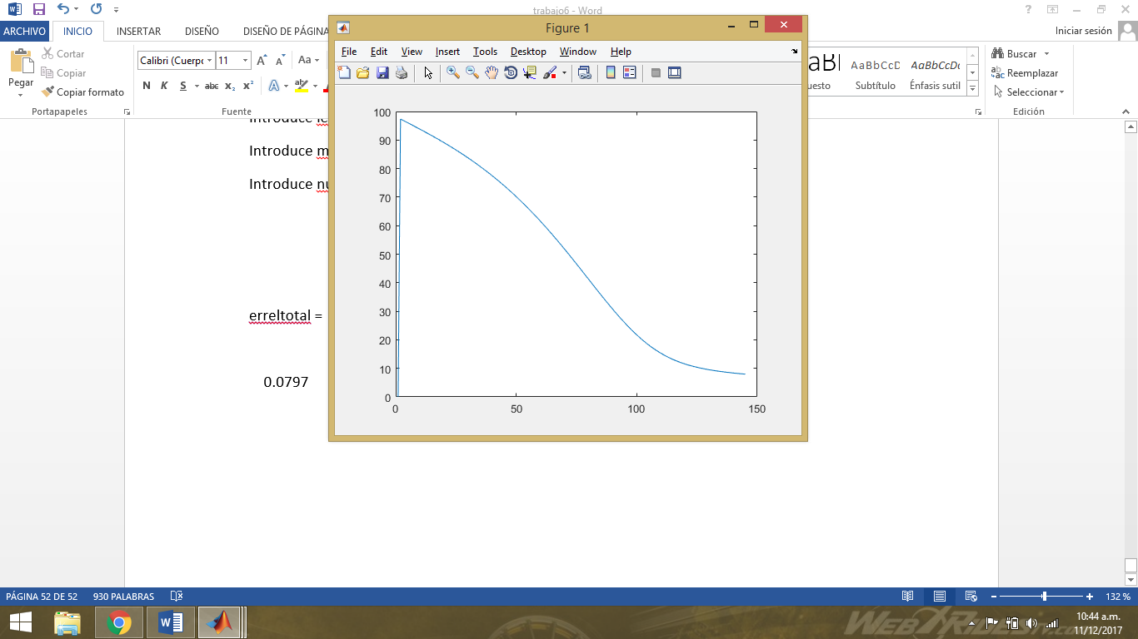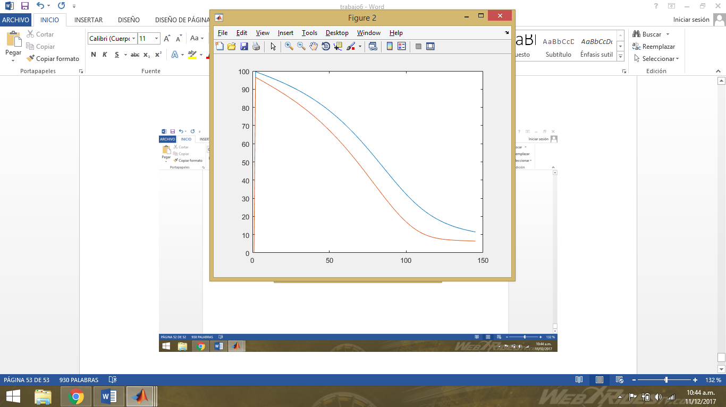

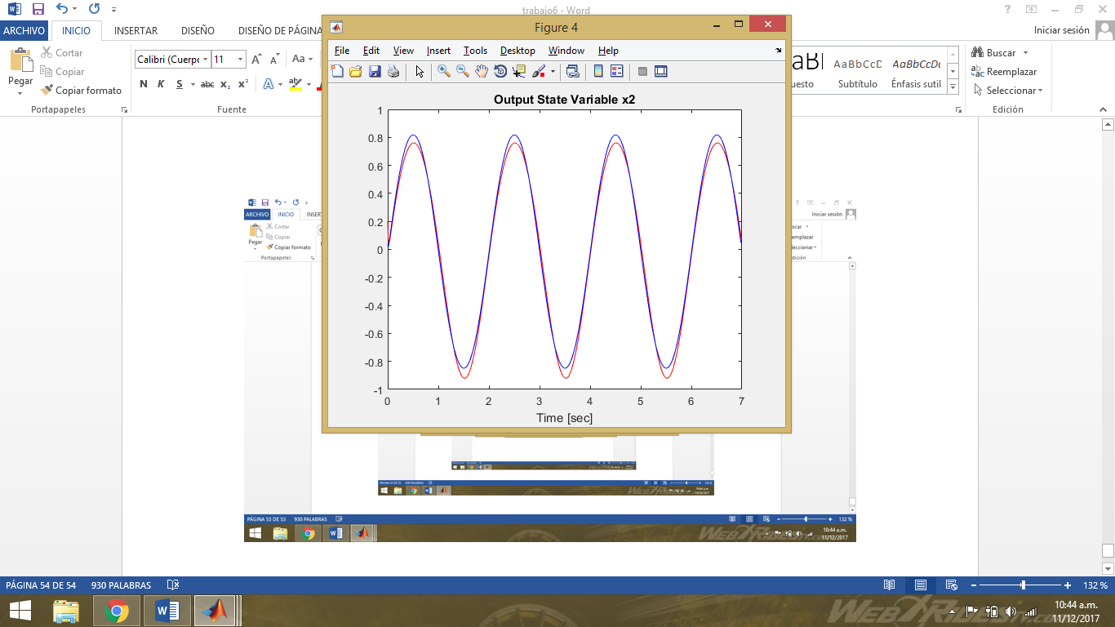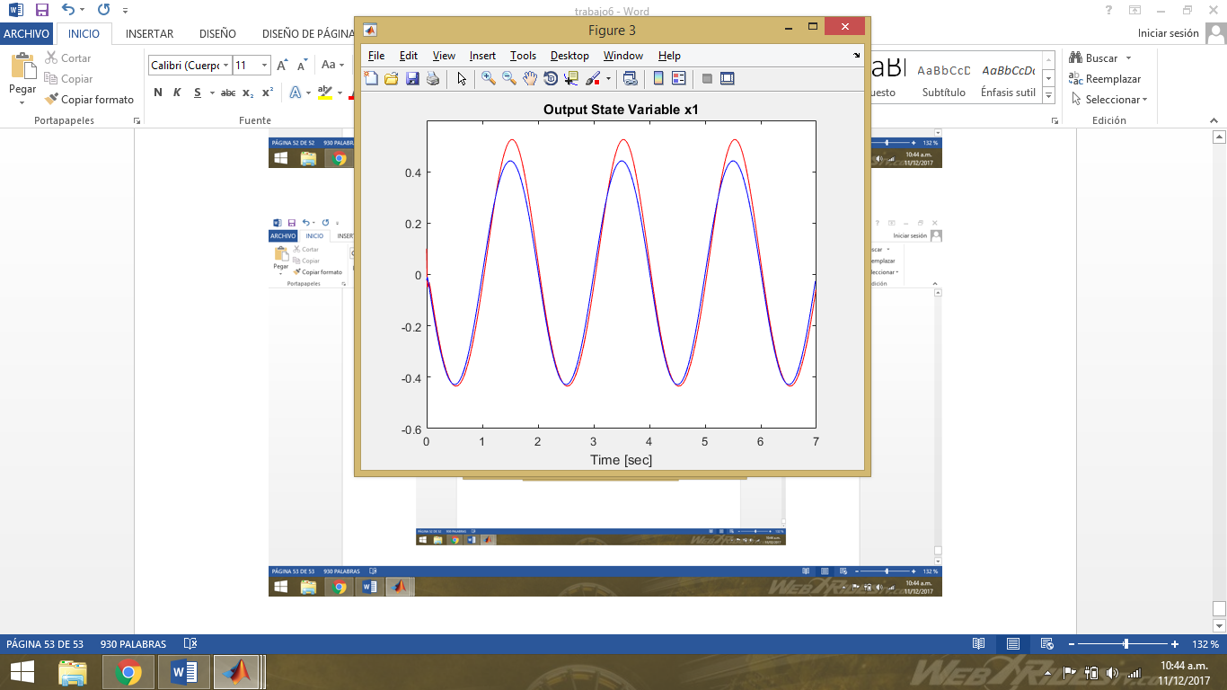

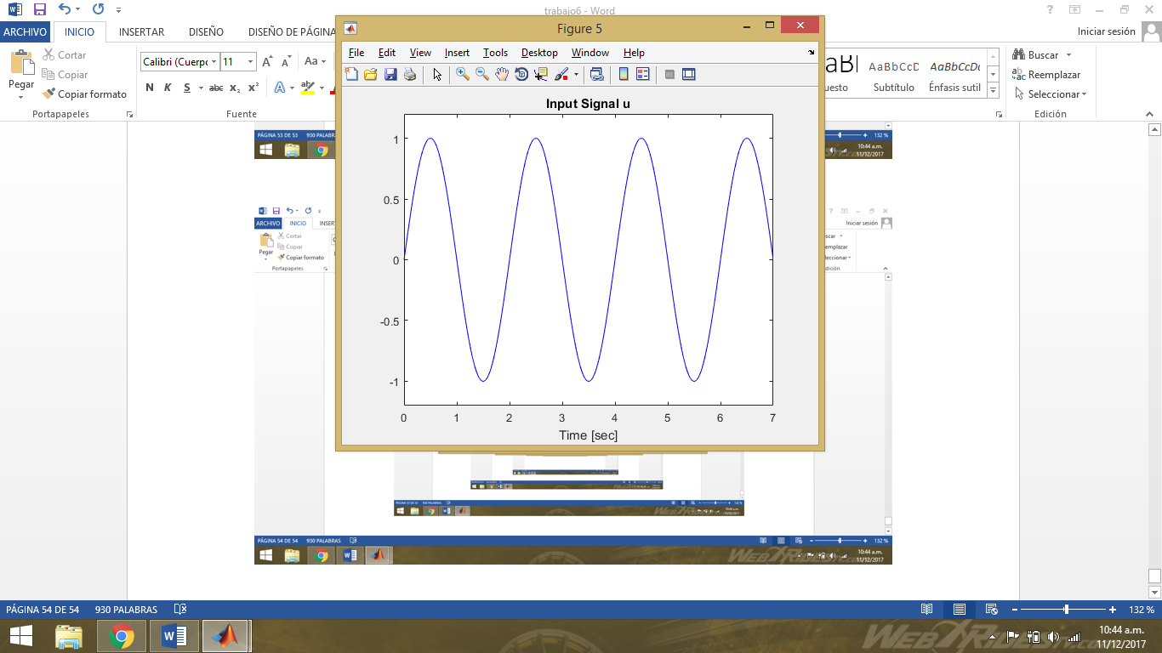

**3.1 Validando_ U2:**

|  |  |
| --- | --- |
| Datos iniciales | Automático |
| learning rate [v w] | 0 |
| learning rate [c: sigmoid center] | 0 |
| learning rate [a: sigmoid slope] | 0 |
| maximum value of error function (percentage %): | 8 |
| number of iteration steps | 3 |
| erreltotal | 0.0849 |

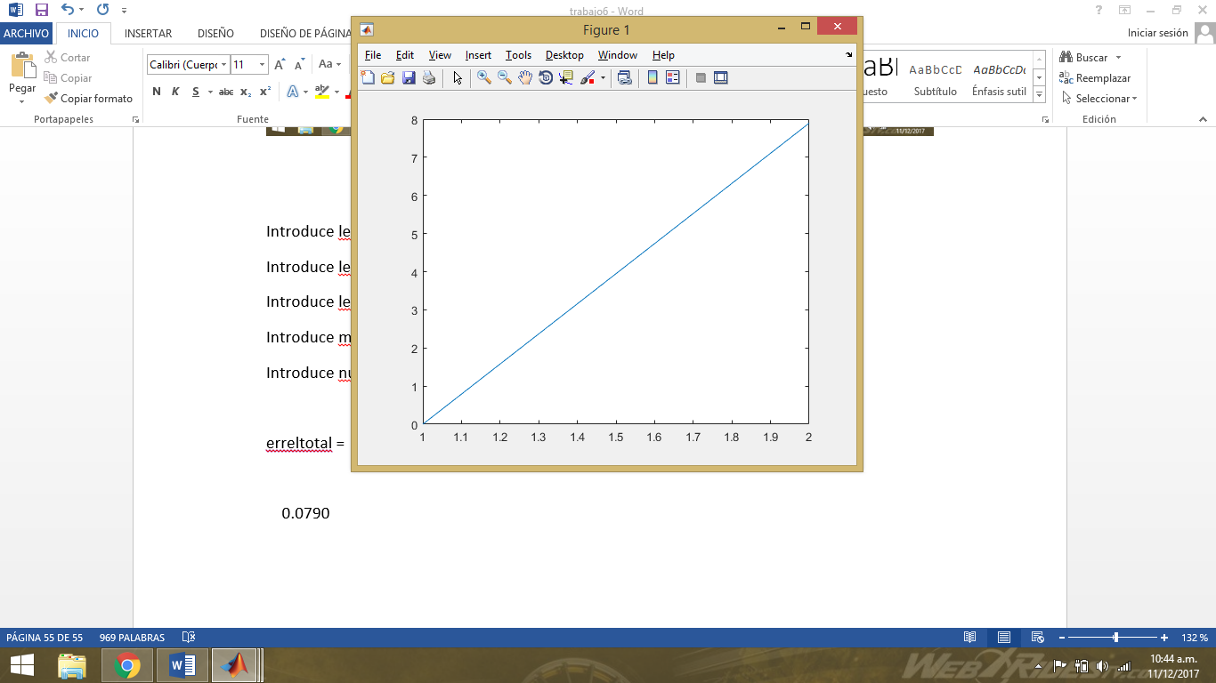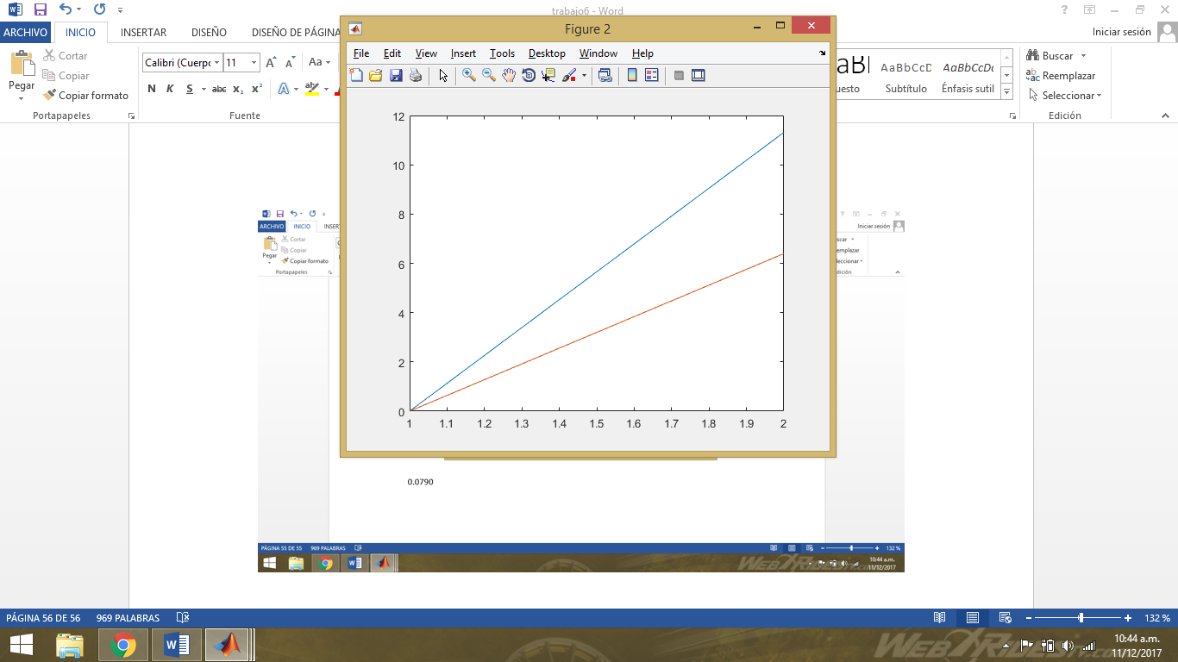

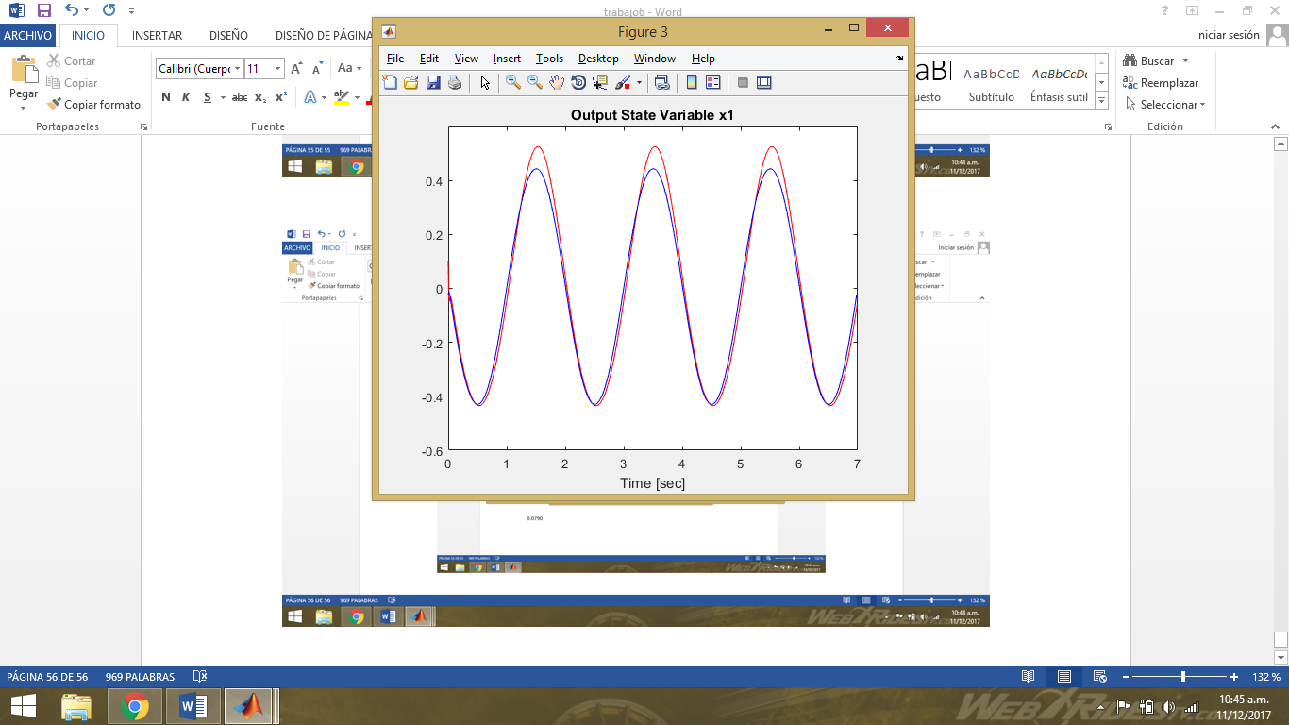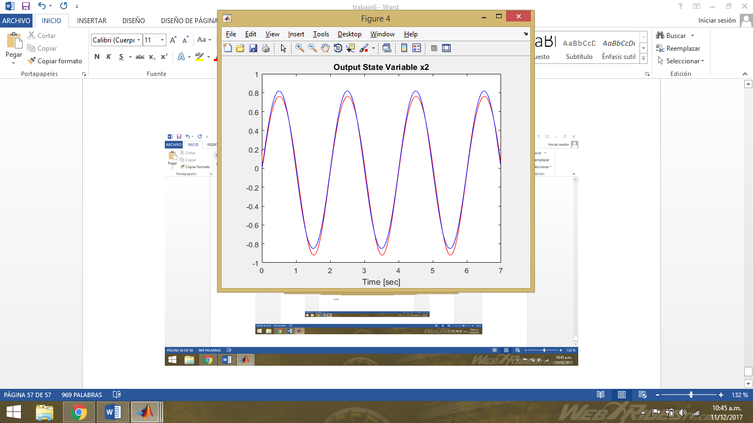

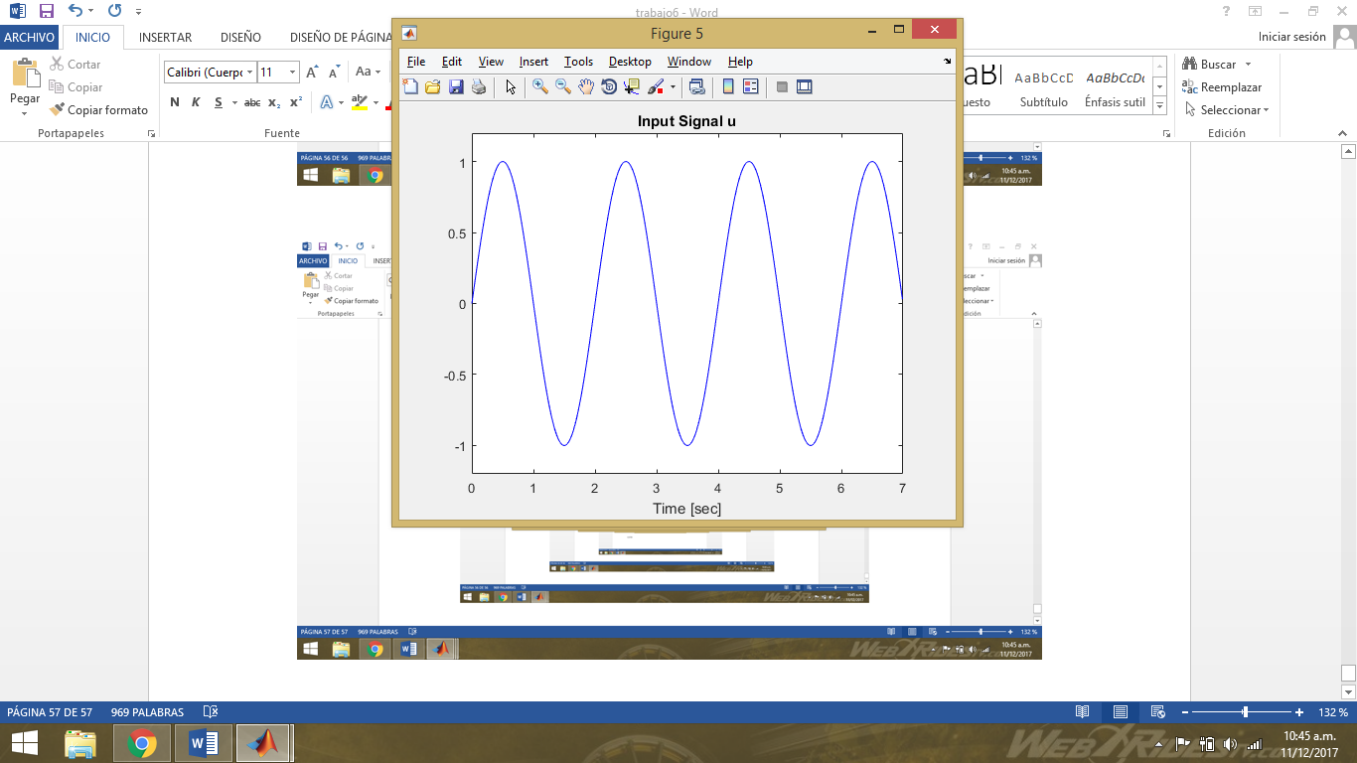

**3.2 Validando_ U3:**

|  |  |
| --- | --- |
| Datos iniciales | Automático |
| learning rate [v w] | 0 |
| learning rate [c: sigmoid center] | 0 |
| learning rate [a: sigmoid slope] | 0 |
| maximum value of error function (percentage %): | 11 |
| number of iteration steps | 3 |
| erreltotal | 0.0863 |







1. **Tercer intento:**
   1. **Entrenamiento_ U1:**

|  |  |
| --- | --- |
| Datos iniciales | Automático |
| learning rate [v w] | 0.05 |
| learning rate [c: sigmoid center] | 0.01 |
| learning rate [a: sigmoid slope] | 0.01 |
| maximum value of error function (percentage %): | 10 |
| number of iteration steps | 900 |
| erreltotal | 0.0947 |

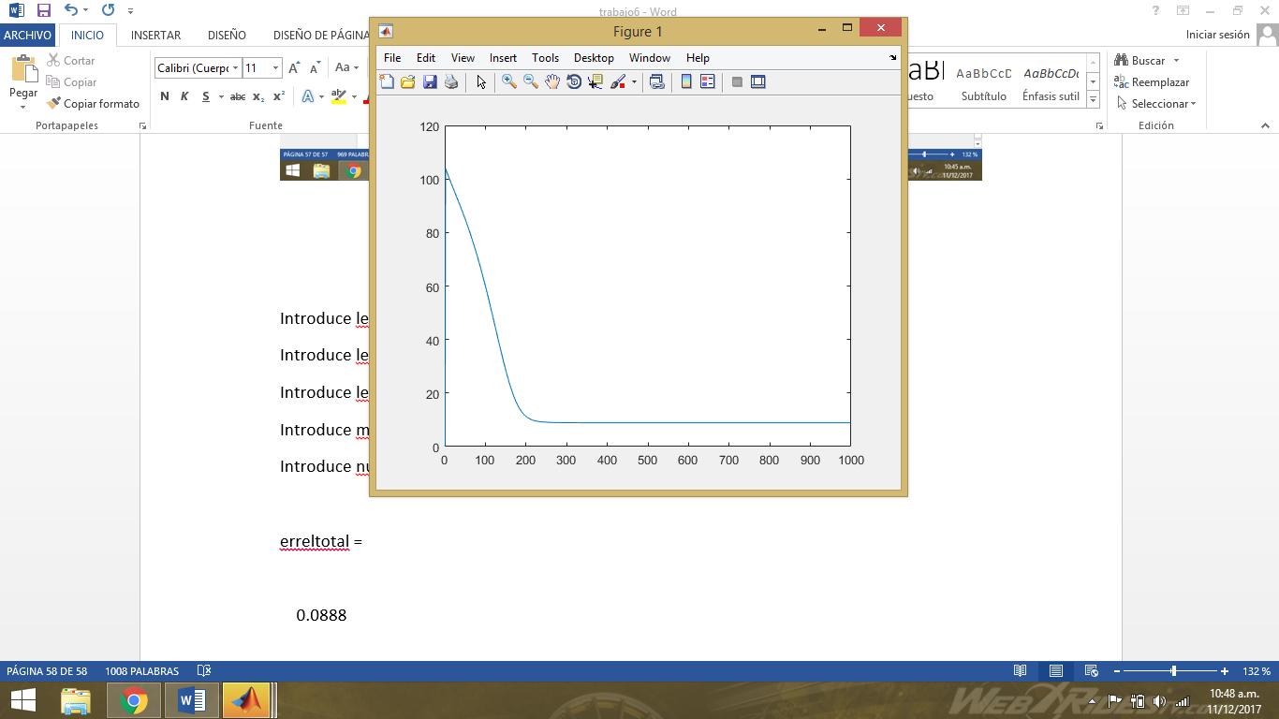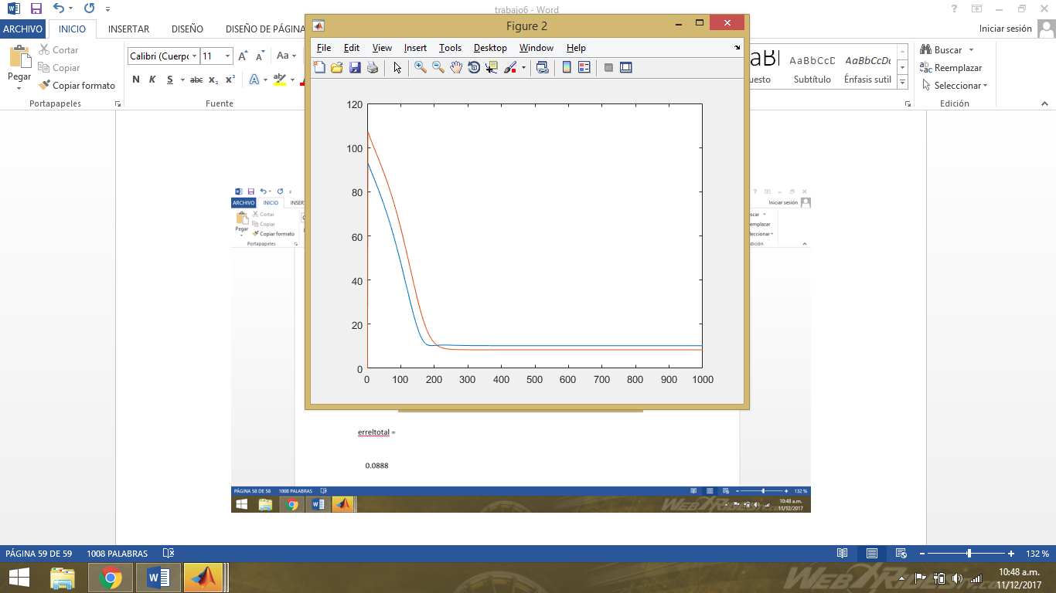

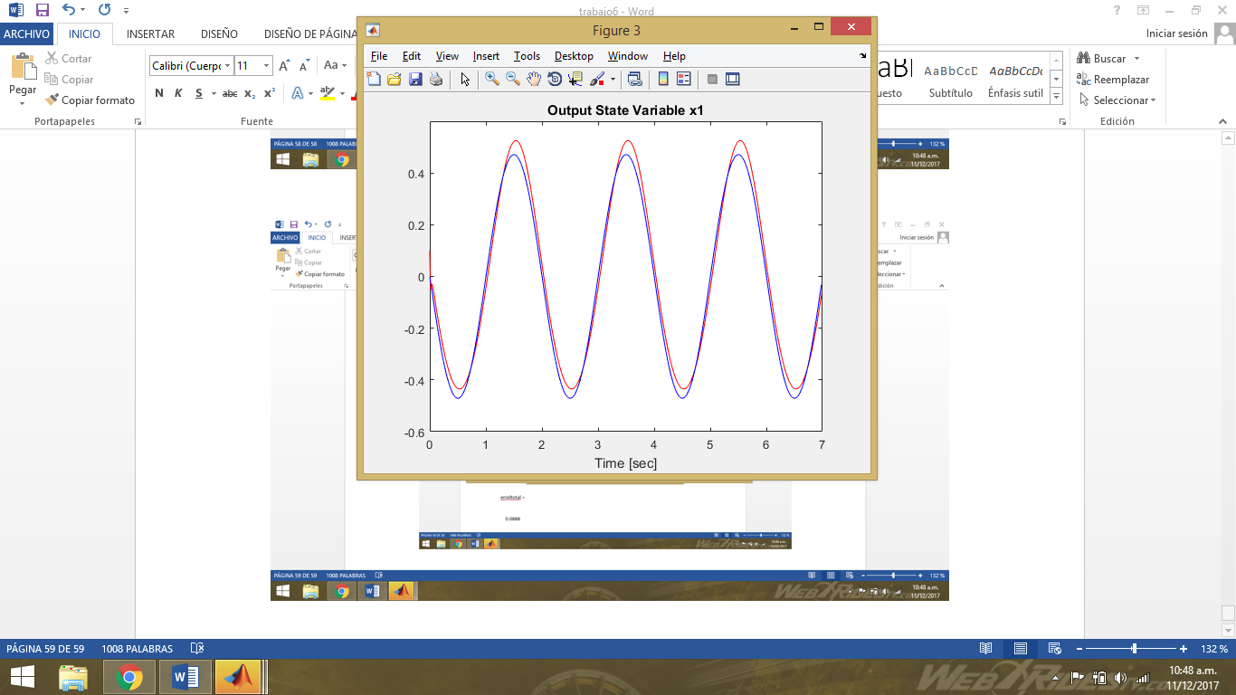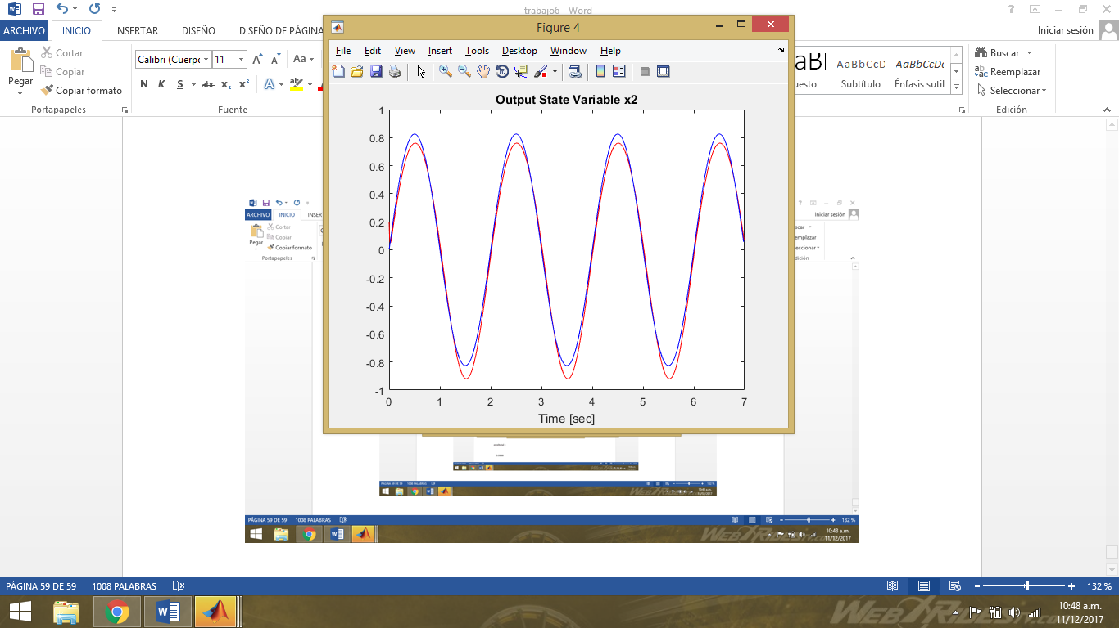

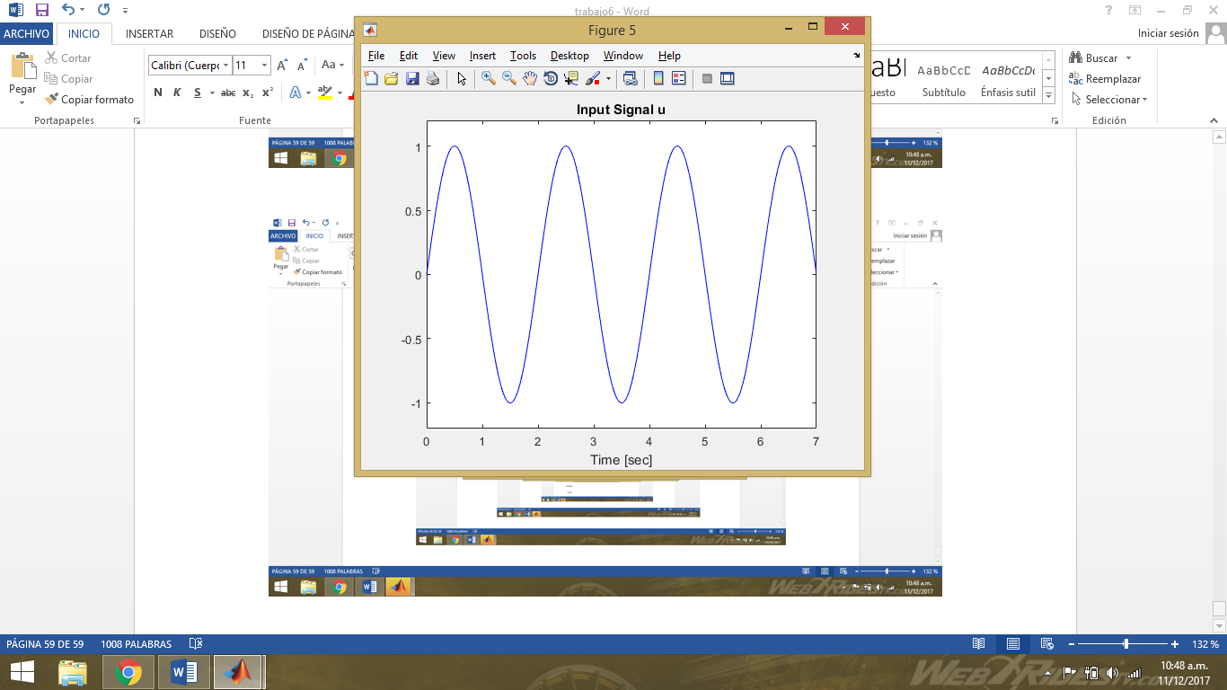

* 1. **Validando_ U2:**

|  |  |
| --- | --- |
| Datos iniciales | Automático |
| learning rate [v w] | 0 |
| learning rate [c: sigmoid center] | 0 |
| learning rate [a: sigmoid slope] | 0 |
| maximum value of error function (percentage %): | 8 |
| number of iteration steps | 2 |
| erreltotal | 0.0785 |

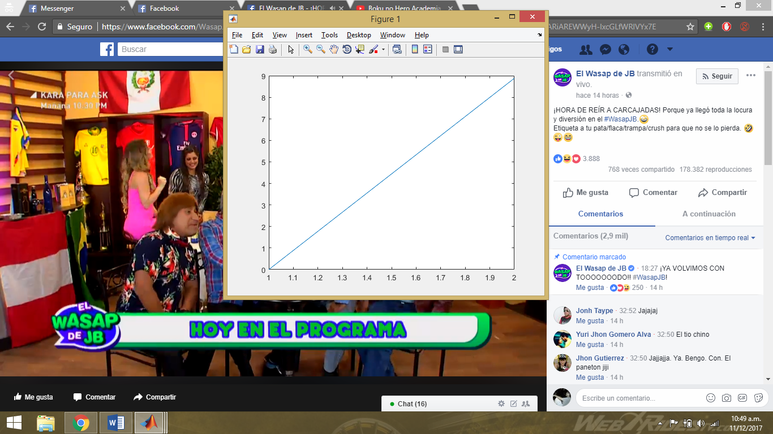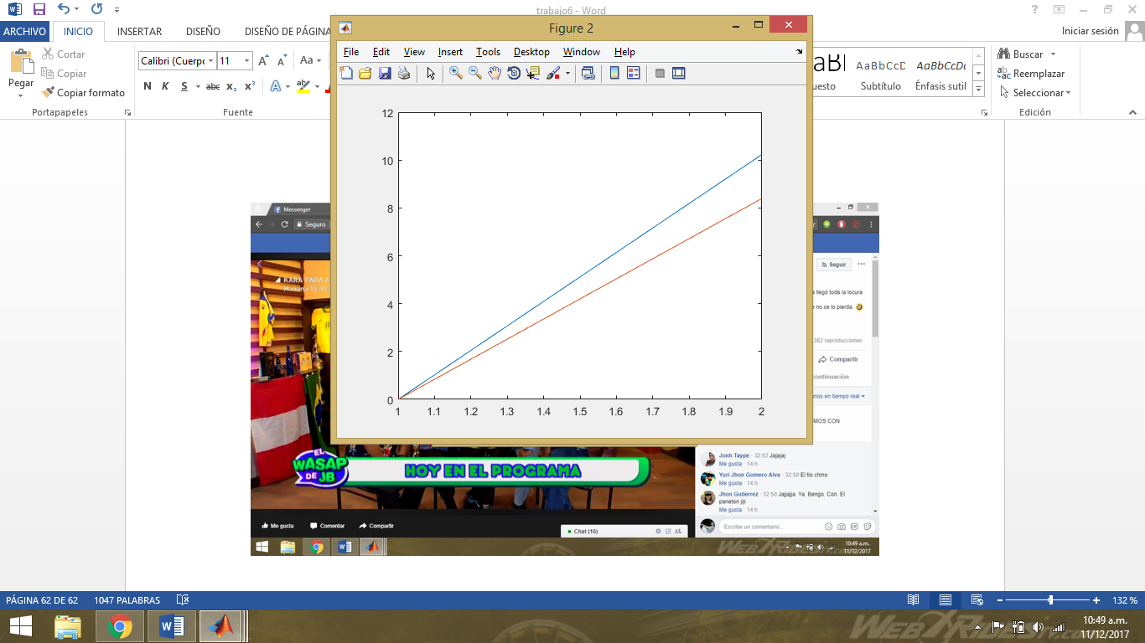

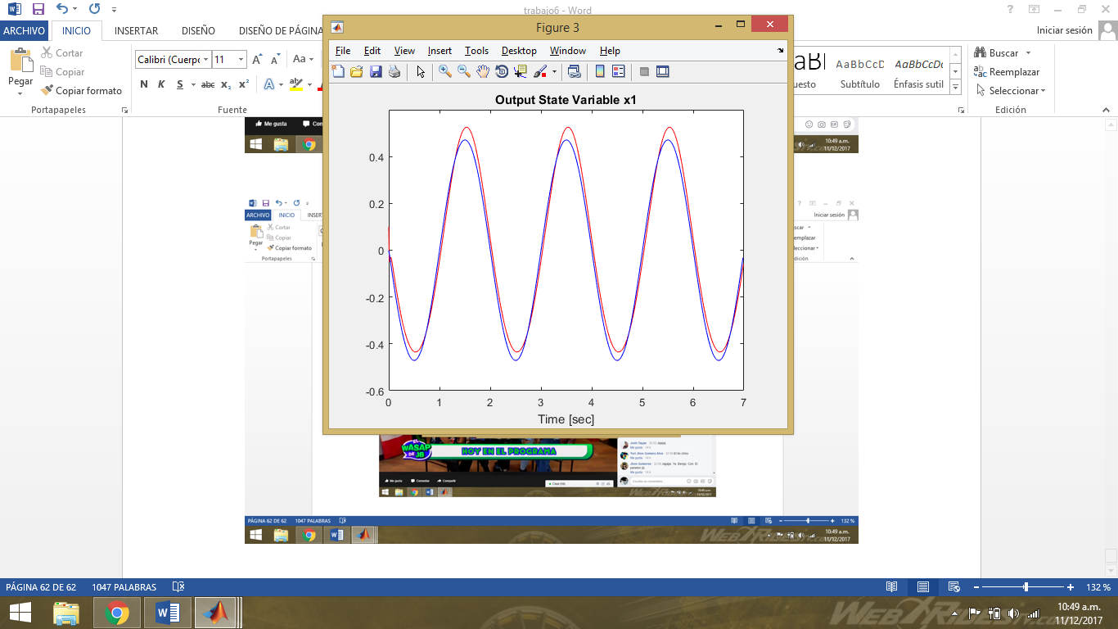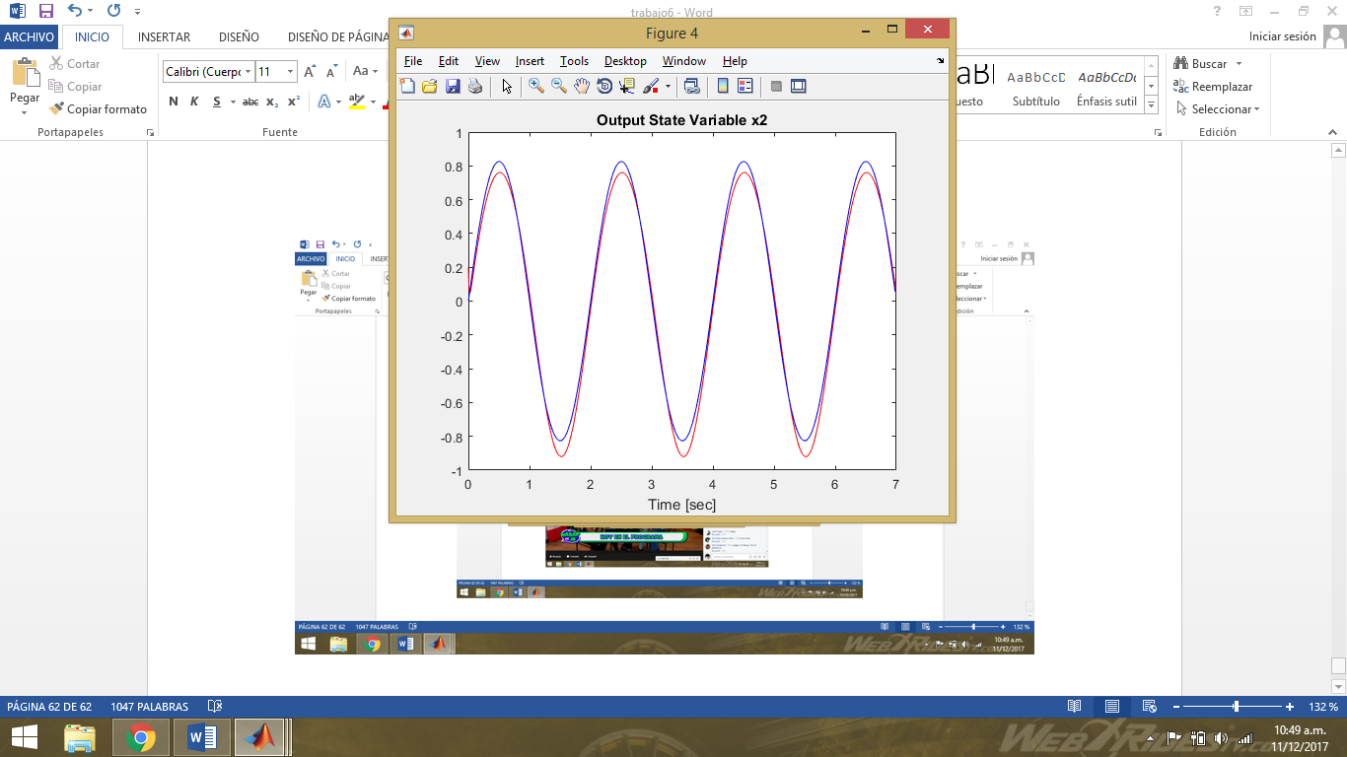

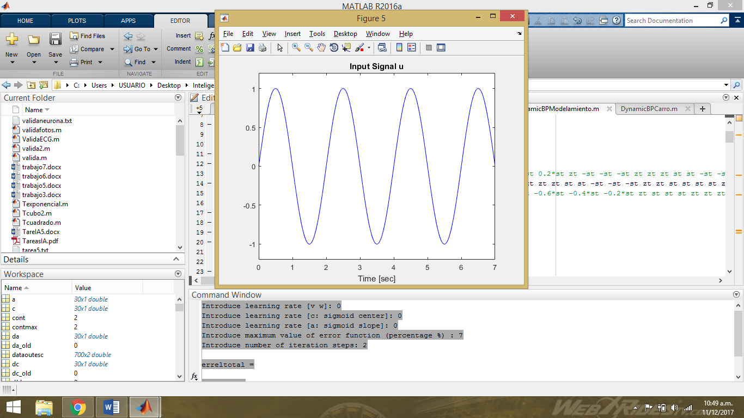

* 1. **Validando_ U3:**

|  |  |
| --- | --- |
| Datos iniciales | Automático |
| learning rate [v w] | 0 |
| learning rate [c: sigmoid center] | 0 |
| learning rate [a: sigmoid slope] | 0 |
| maximum value of error function (percentage %): | 8 |
| number of iteration steps | 2 |
| erreltotal | 0.0752 |







CONCLUSIÓN

Como observamos cuando los valores de eta son pequeños (0 < eta < 0.05), y los valores de “a” y “c” son “0” podemos notar en las gráficas que los resultados (rojo) se aproximan más a lo que queremos que salga (azul), y en caso contrario el error que obtenemos es mayor.